Encrypting METAR codes

# Order of a METAR code

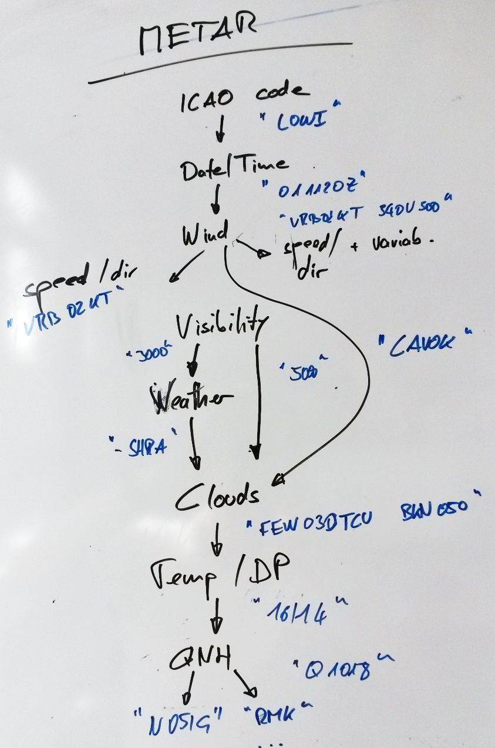

# Information in a METAR code

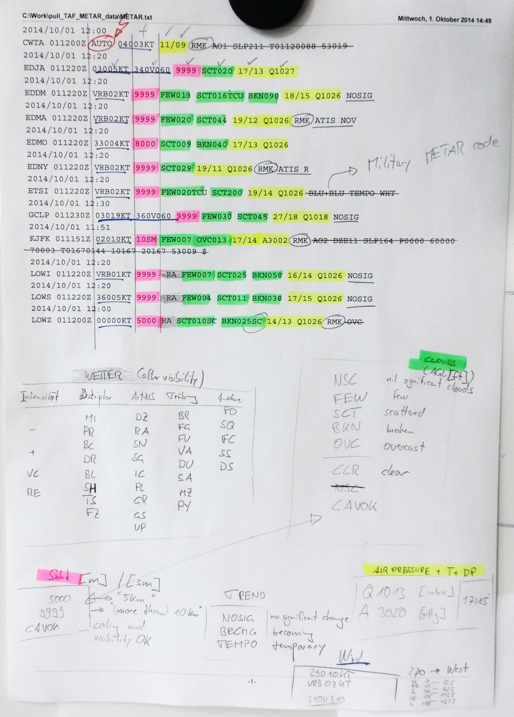

# Good METAR translation

|  |  |
| --- | --- |
| Output produced by METARs form (1324 UTC 01 October 2014) found at <http://www.aviationweather.gov/adds/metars/> | |
|  | |
| **METAR text:** | **ETSI 011220Z VRB02KT 9999 FEW020TCU SCT200 19/14 Q1026 BLU+BLU TEMPO WHT** |
| **Conditions at:** | ETSI (INGOLSTADT(GER-M, DE) observed 1220 UTC 01 October 2014 |
| **Temperature:** | 19.0°C (66°F) |
| **Dewpoint:** | 14.0°C (57°F) [RH = 73%] |
| **Pressure (altimeter):** | 30.30 inches Hg (1026.0 mb) |
| **Winds:** | variable direction winds at 2 MPH (2 knots; 1.0 m/s) |
| **Visibility:** | 6 or more miles (10+ km) |
| **Ceiling:** | at least 12,000 feet AGL |
| **Clouds:** | few clouds at 2000 feet AGL scattered clouds at 20000 feet AGL |
| **Weather:** | no significant weather observed at this time |